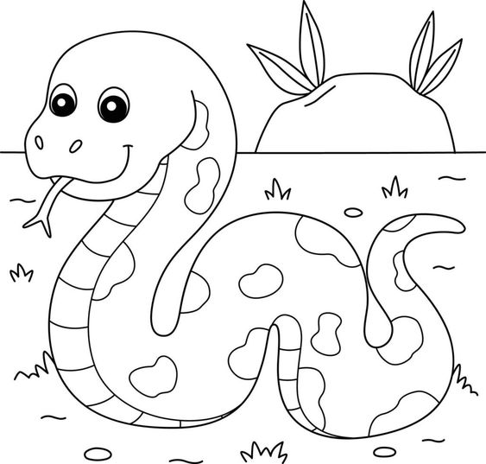

**Lớp Ba/11**

**Xuân**

**Ất Tỵ**

**Chúc**

**Mừng**

**Năm**

**Mới**

**2025**

**Lớp Ba/11**

**Chúc**

**Mừng**

**Năm**

**Mới**

**2025**

**Chúc**

**Mừng**

**Năm**

**Mới**

**2025**

**Lớp Ba/11**

**Ất Tỵ**

**Lớp Ba/11**

**Chúc**

**Mừng**

**Năm**

**Mới**

**2025**

**Lớp Ba/11**

**CUNG**

**CHÚC**

**TÂN**

**XUÂN**

**2025**

**XUÂN Ất Tỵ**

**‘2025**

**VẠN**

**SỰ**

**NHƯ**

**Ý**

**Lớp Ba/11**

**Lớp Ba/11**

**‘2025**

**PHÁT**

**TÀI**

**PHÁT**

**LỘC**

**Ất Tỵ**

**‘2025**

**AN**

**KHANG**

**THỊNH**

**VƯỢNG**

**Lớp Ba/11**

**Ất Tỵ**

**Lớp Ba/11**

**Chúc**

**Mừng**

**Năm**

**Mới**

**2025**

**Lớp Ba/11**

**‘2025**

**VẠN**

**SỰ**

**NHƯ**

**Ý**

**Lớp Ba/11**

**‘2025**

**AN**

**KHANG**

**THỊNH**

**VƯỢNG**

**XUÂN Ất Tỵ**

**Lớp Ba/11**

**‘2025**

**PHÁT**

**TÀI**

**PHÁT**

**LỘC**